

API Security Risk Analysis Report
Prepared by
Mokoena Lebohang Solomon

2026

Contents
Executive Summary 3
Scope of Assessment 4
Methodology 5
Testing Evidence 6
Key Findings & Risk Analysis 7
Risk Summary 11
Business Impact Analysis 12
Conclusion 13

Executive Summary
Modern SaaS applications rely heavily on APIs to enable communication between web platforms, mobile applications, and third-party services. While APIs improve efficiency and scalability, insecure APIs introduce significant risks such as unauthorized data access, data leakage, and service abuse.

This assessment was conducted on a publicly available test API using industry-standard tools including Browser Developer Tools and Insomnia. The objective was to simulate a real-world API security review without performing any intrusive or harmful actions.

The analysis identified several common API security weaknesses, particularly in authentication, authorization, and data exposure.
Overall Risk Rating: Medium to High

If similar vulnerabilities exist in a production SaaS environment, they could lead to data breaches, compliance violations, and reputational damage.

Scope of Assessment
API Tested
JSONPlaceholder
Base URL: https://jsonplaceholder.typicode.com

Testing Tools
Insomnia

Testing Approach
Read-only API interaction
Safe request testing (GET and limited POST)
Header and response inspection

Methodology

The assessment followed a structured API security testing approach:

Reviewed API documentation
Sent API requests using Insomnia

Analyzed:
Authentication mechanisms
Authorization controls
Response data exposure
Mapped findings to the OWASP API Security Top 10

Testing Evidence
Example Requests Performed
GET /users
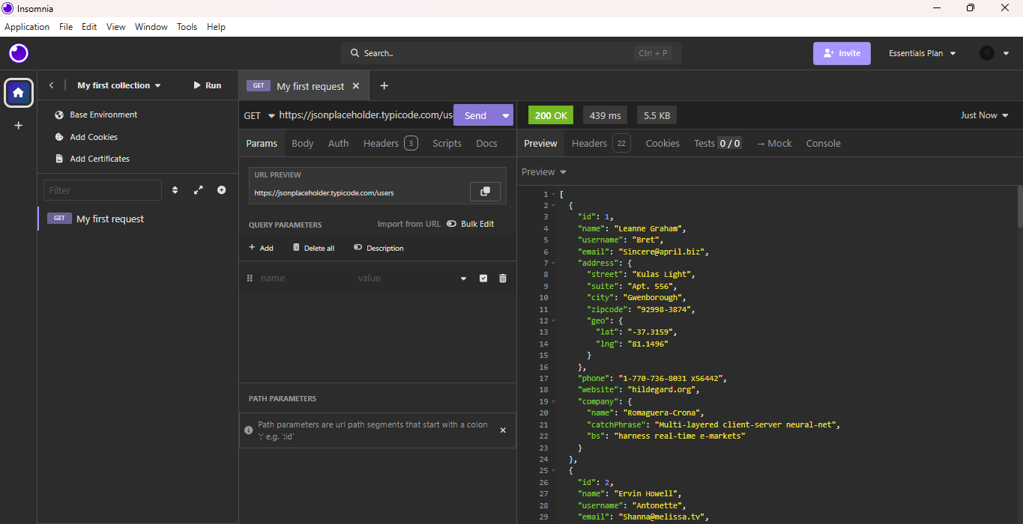

GET Specific User
GET /users/2
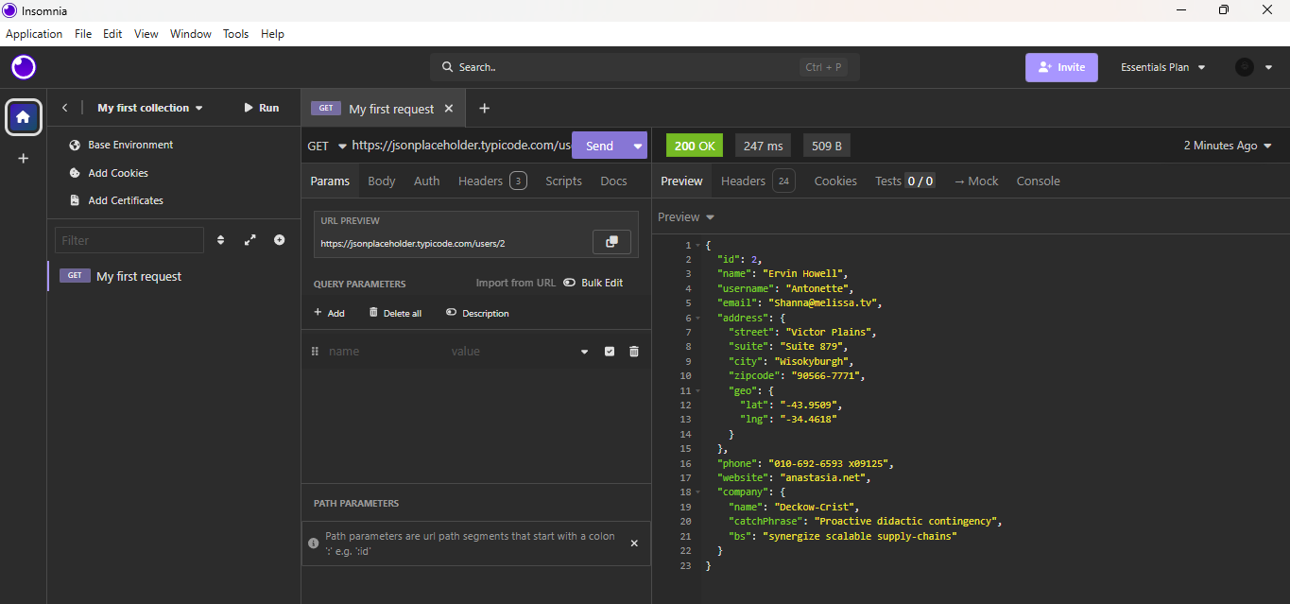

POST Request
POST /posts
Key Observations
No authentication required
Full user data returned
No restrictions on accessing other users’ data
API accepts arbitrary input

Key Findings & Risk Analysis
Unauthenticated Endpoints
Description: All API endpoints are publicly accessible without authentication.

Evidence: /users accessible without login
No API key or token required
Risk Level: High
Business Impact: Unauthorized access to sensitive data. Data scraping by attackers Loss of customer trust

Remediation:
Implement authentication (OAuth 2.0, API keys, JWT)
Enforce authentication on all endpoints

Broken Authorization (BOLA)
Description: The API does not restrict access to user-specific data.
Evidence: /users/2 accessible by any requester
Risk Level: High
Business Impact: Exposure of other users’ data, Regulatory non-compliance (e.g., POPIA)
Remediation: Implement Role-Based Access Control (RBAC), Validate user permission per request

Excessive Data Exposure
Description: API responses return more information than necessary.
Exposed Data Includes:
- Email
- Address
- Company details
Risk Level: Medium

Business Impact: Increased risk of data leakage, Privacy violations

Remediation:
- Return only necessary fields
- Implement response filtering

Missing Rate Limiting
Description: No evidence of request throttling or rate limiting.
Risk Level: Medium
Business Impact:
- API abuse (bots, scraping)
- Potential service downtime
Remediation:
- Implement rate limiting (e.g., 100 requests/minute)
- Use API gateways

Security Misconfiguration (Headers)

Description: Important HTTP security headers are missing.

Examples:
- Content-Security-Policy
- X-Frame-Options
Risk Level: Low
Business Impact: Increased exposure to web-based attacks
Remediation: Configure secure headers at server/API gateway level

Input Validation Issues
Description: POST endpoints accept arbitrary input without validation.
Risk Level: Low to Medium
Business Impact:
- Risk of injection attacks in real systems
- Data integrity issues
Remediation:
- Validate all inputs server-side
- Use schema validation (JSON Schema)

Risk Summary

Risk | Severity | Impact
Unauthenticated Access | High | Data exposure
Broken Authorization | High | Cross-user data access
Excessive Data Exposure | Medium | Privacy risks
Missing Rate Limiting | Medium | API abuse
Security Misconfiguration | Low | Weak protection
Input Validation Issues | Low-Medium | Data integrity risks

OWASP API Top 10 Mapping
Finding | OWASP Category
Broken Authorization | API1: Broken Object Level Authorization
No Authentication | API2: Broken Authentication
Excess Data Exposure | API3: Broken Object Property Level Authorization
No Rate Limiting | API4: Unrestricted Resource Consumption
Security Headers Missing | API8: Security Misconfiguration
Input Validation Issues | API10: Unsafe Consumption of APIs

Business Impact Analysis
If these vulnerabilities were present in a real SaaS platform, the organization could face:
- Data breaches
- Regulatory penalties (e.g., POPIA in South Africa)
- Reputational damage
- Financial losses from abuse or downtime

Attack Scenario
An attacker could:
- Send requests to /users
- Collect all user data
- Access individual user records
- Automate scraping using scripts
- Overload the API due to lack of rate limiting

Recommendations
Immediate Actions
- Enforce authentication on all endpoints
- Implement authorization controls (RBAC)

Short-Term
- Apply rate limiting and monitoring
- Minimize exposed data

Long-Term
- Deploy API Gateway (e.g., AWS API Gateway)
- Implement logging and anomaly detection
- Conduct regular API security audits

Conclusion
This API security assessment demonstrates how common vulnerabilities—such as lack of authentication and poor access control—can expose SaaS platforms to serious risks.
Although the tested API is intentionally open for learning purposes, the findings reflect real-world security issues frequently observed in production environments.
Aligning API security practices with the OWASP standards significantly reduces risk and strengthens overall application security.

